# Use Case Descriptions

## **Customer:**

### Log In

The Log In use case prompts the user for their Username and Password that were created earlier. If new user the system prompts them to create an account.

### Create Account

The Create Account use case prompts the user to create a new User name along with an associated password they will need to remember for accessing the site. First name, last name, home address, email, phone number, will be recorded. Customer ID is created upon account creation and is done as a random integer.

### Contact Shipping Store

The Contact Shipping Store use case allows the customer to contact the Shipping Store via email. To send a message, the customer needs to have first created an account. Customer ID, first name, last name, should be included along with their inquiry. The message is added to a queue of unanswered messages. The message can be read or replied to by email by an Employee or Software Administrator.

### Edit Account

The Edit Account use case allows the customer to edit any information they may have entered incorrectly or need to update inside their account. The information they are allowed to edit are: First name, last name, address, user name, email, password, and phone number.

### Track Package

The Track Package use case allows the customer to see the status of their package(s) after they have created a transaction. The customer will input the tracking number provided to them upon creating a transaction. If the tracking number does exist, the website will provide the user information based on that transaction and the delivery status of the package as well as when it was last picked up and where it was last scanned.

### Print Receipt or Shipping Label(Shared by Employee)

The Print Receipt or Shipping Label use case allows the user to print out a receipt or shipping label for their records after they have created a shipping transaction.

### Create Transaction (Shared by Employee)

The Create Transaction use case allows a customer to create a shipping transaction. Initially the Employee ID is left empty (since there is no employee involved yet) and the transaction status is set to Pending. Later, when the package is dropped off to the store, the employee ID is populated with the ID of the employee who collected the package, and the transaction status is set to Active. If the shipping transaction is created in store then the Employee must create the shipping transaction and their ID is populated in the Employee ID section and the transaction status is set to Active.

## **Employee:**

### Reply

The Reply use case allows an employee to reply to the queue of customer’s unanswered messages. Message reply is sent via email to customer using the email provided on their account.

### Show All Packages in Inventory

The Show All Packages in Inventory use case allows the Employee to view the information about the packages currently in the inventory. A package is in the inventory if it has been shipped but not yet delivered to its final destination. All packages contain a tracking location field that provides the address of where the last scan of the package has happened.

### Collect Package from Customer

The Collect Package from Customer use case allows the employee to collect a package from the customer. The status of the transaction is set to Active and the package is then added to the inventory.

### Deliver Package to Final Destination

The Deliver Package to Final Destination use case allows the employee to deliver the package to the package’s final destination. The package is then removed from the inventory and the status of the transaction is set to completed.

### Add Customer Info

The Add Customer Info use case allows the employee to manually enter in the customer info into the database at the customer’s discretion. This is usually done for customers within the store.

### Edit Customer Info

The Edit Customer Info use case allows the employee to manually edit the customer info into the database at the customer’s discretion.

## **Software Administrator (Inherits all Employee Cases):**

### Accounting Update

The Accounting Update use case allows the Software Admin to update the accounting information (income, expenses, and profit) every time a new package is shipped or an expense is paid.

### Accounting Info

The Accounting Info use case allows the Software Admin to keep track of the income, expenses, and profit. Optionally can print any financial documents for further viewing.

### Print Financial Documents

The Print Financial Documents use case allows the Software Admin to print out financial documents such as: Balance Sheets, Cash Flow Statements, and Invoices.

### Add Employee or Admin

The Add Employee or Admin use case allows the Software Admin to create a new Employee or Admin account into the database.

### Edit Employee or Admin

The Edit Employee or Admin use case allows the Software Admin to edit an Employee or Admin information into the database.

### Access Accounting Management

The Access Accounting Management use case allows the Software Admin to access the Accounting Management part of the software.

# Use Case Diagram

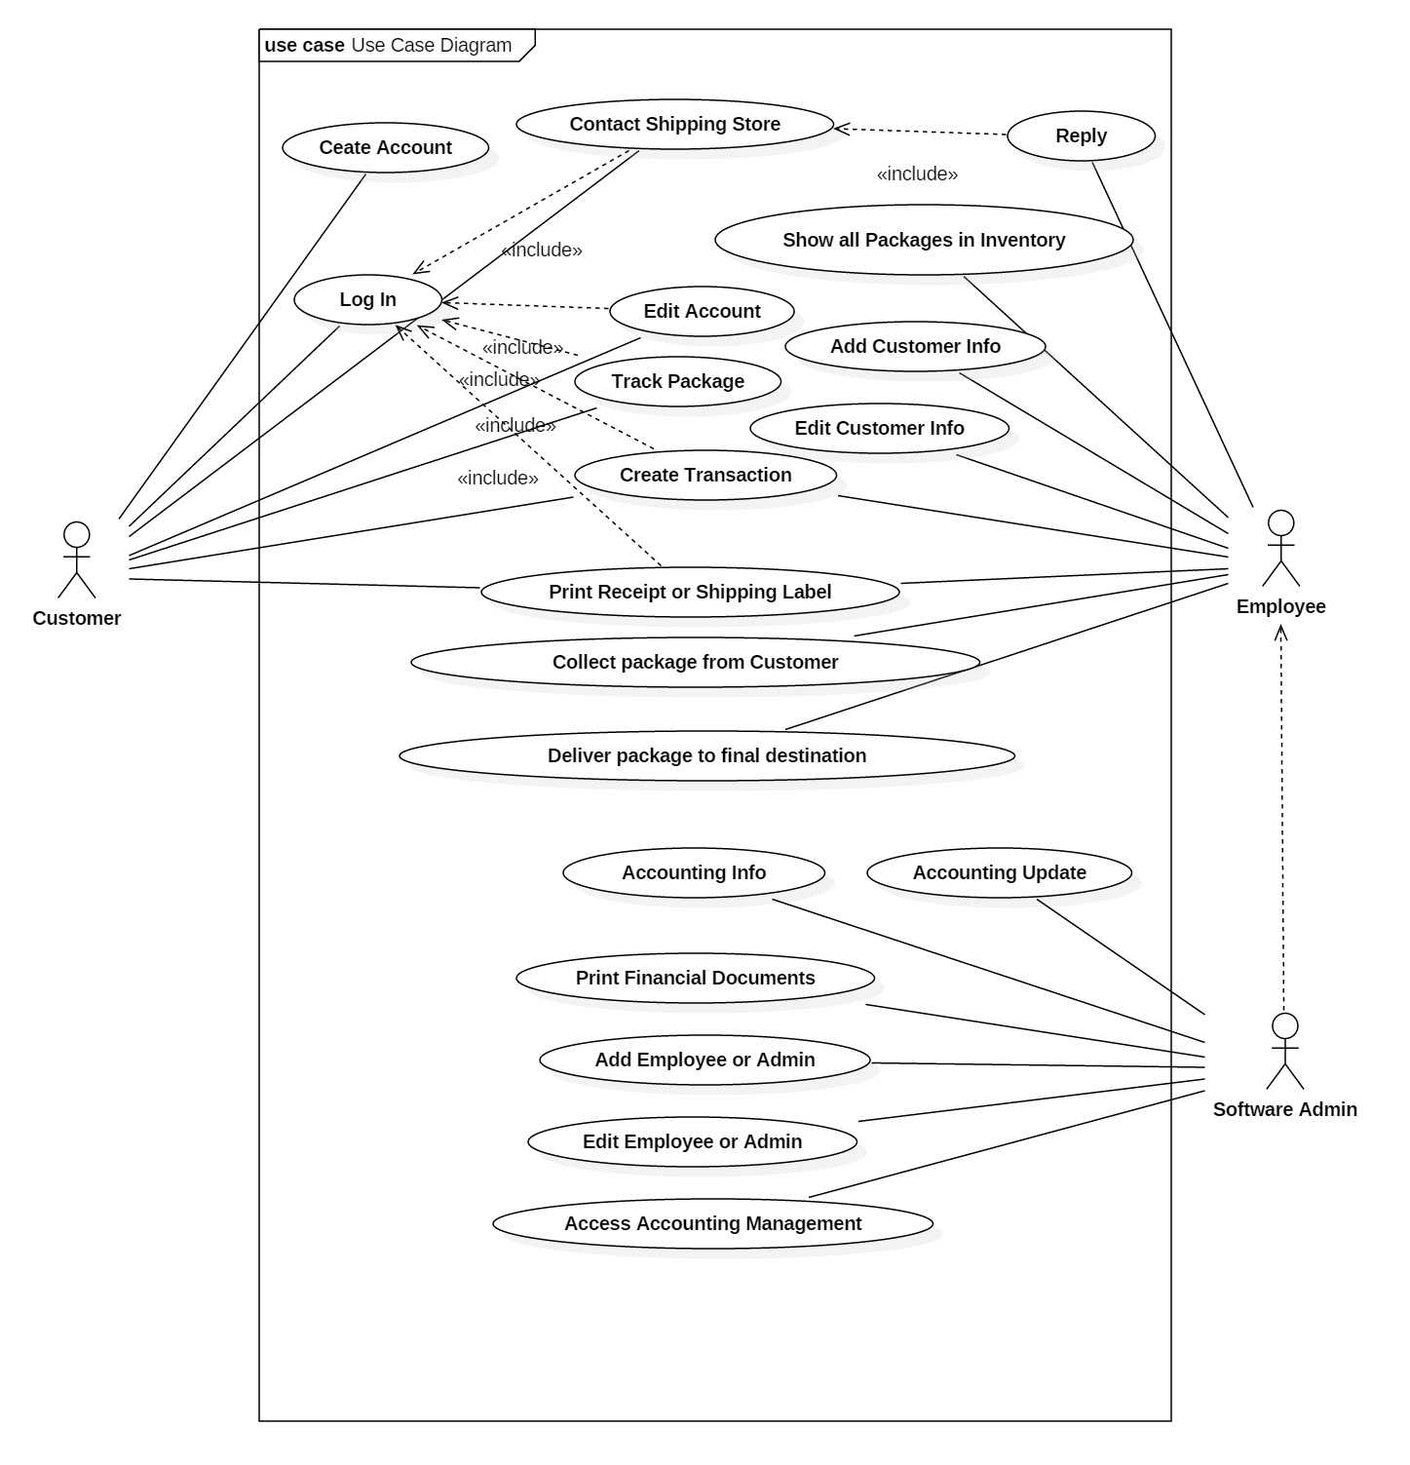

# Class Diagram

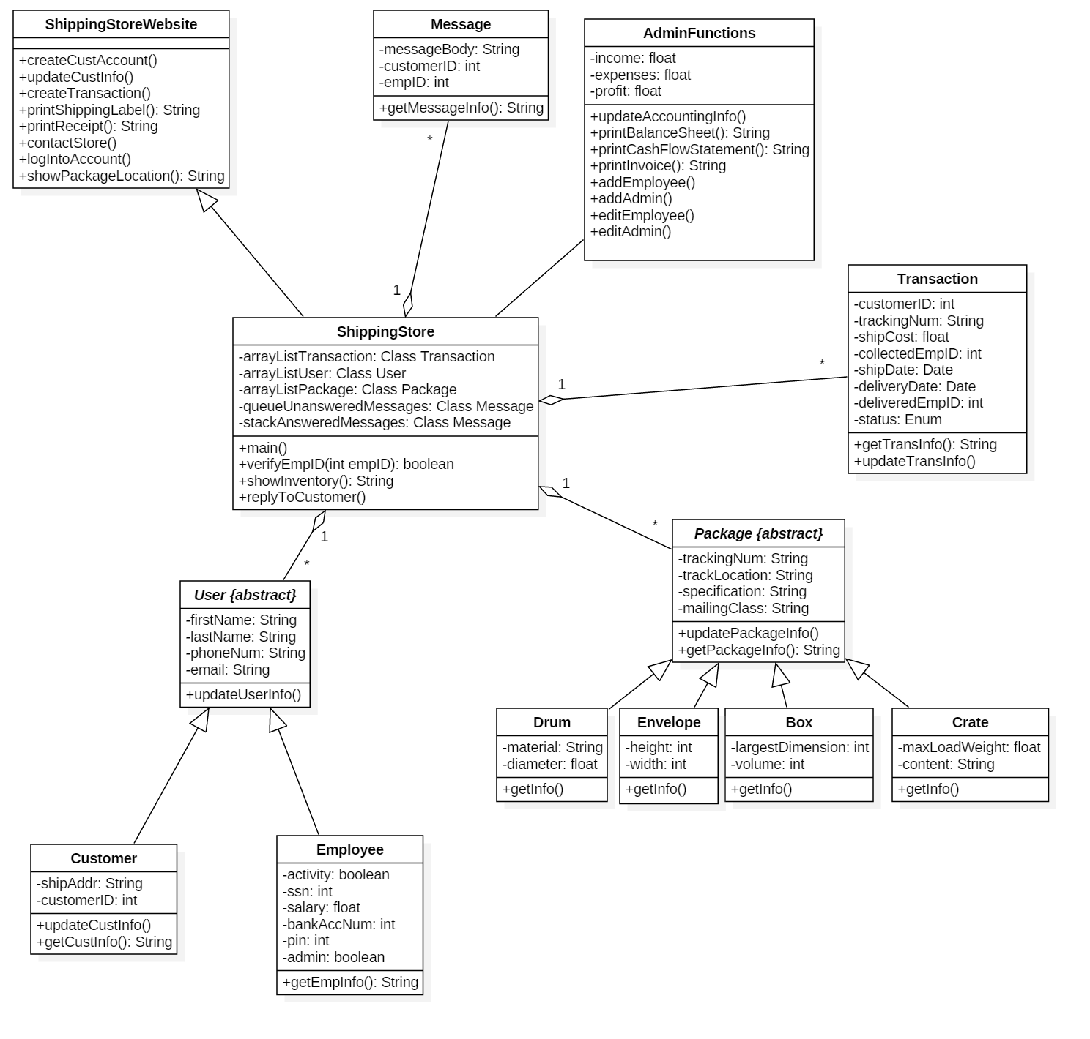

# CRC Cards

# Sequence Diagram

# State Machine Diagram